Albumify

Project Report Submitted by:

Khush Desai, 10931121018
Sairantri Pathak, 10931121016
Atreyee Bose, 10931121013
Pratik Adhikary 10931121033

Under the guidance of:

Mr. Abhisek Saha

A Project Submitted in Partial Fulfillment of the Requirements for the Degree of Bachelor of Technology in Computer Science and Business Systems



Department of Computer Science & Business System
Netaji Subhas Engineering College
Garia, Kolkata – 700152
Academic Year 2024-2025
Certificate

This is to certify that this project report titled Albumify submitted in partial fulfillment of requirements for award of the degree Bachelor of Technology (B. Tech) in Computer Science and Business System of Maulana Abul Kalam Azad University of Technology is a faithful record of the original work carried out by,

Khush Desai, 10931121018, 211090131110018, 2021-22
Sairantri Pathak, 10931121016, 211090131110016, 2021-22
Pratik Adhikary, 10931121033, 211090131110047, 2021-22
Atryeee Bose, 10931121013, 211090131110008, 2021-22

under my guidance and supervision.

It is further certified that it contains no material, which to a substantial extent has been submitted for the award of any degree/diploma in any institute or has been published in any form, except the assistance drawn from other sources, for which due acknowledgement has been made.

Date:
--------------------------------------
Mr. Abhisek Saha
Assistant Professor (CSBS, NSEC)

--------------------------------------
Dr. Partha Ghosh
Head of Department of Computer Science & Business System
Netaji Subhas Engineering College.
Garia, Kolkata – 700152
DECLARATION

We hereby declare that this project report titled Albumify is our own original work carried out as an undergraduate student in Netaji Subhash Engineering College except to the extent that assistance from other sources are duly acknowledged.

All sources used for this project report have been fully and properly cited. It contains no material which to a substantial extent has been submitted for the award of any degree/diploma in any institute or has been published in any form, except where due acknowledgement is made.

Student’s names: Signatures: Dates:



Khush Desai



Sairantri Pathak



Pratik Adhikary


Atreyee Bose

CERTIFICATE OF APPROVAL

We hereby approve this dissertation titled Albumify
carried out by

Khush Desai, 10931121018, 211090131110018, 2021-22
Sairantri Pathak, 10931121016, 211090131110016, 2021-22
Pratik Adhikary, 10931121033, 211090131110047, 2021-22
Atryeee Bose, 10931121013, 211090131110008, 2021-22

under the guidance of Mr. Abhisek Saha (Assistant Professor, CSBS, NSEC) of Netaji Subhash Engineering College, Kolkata in partial fulfillment of requirements for award of the degree Bachelor of Technology (B. Tech) in Computer Science and Business System of Maulana Abul Kalam Azad University of Technology

Date:

- ………………………………………….

- ………………………………………….

Examiners’ signatures:

Acknowledgement

We would like to extend our profound gratitude to everyone who has supported us in the successful completion of our final year project, "Albumify".

First and foremost, we are deeply thankful to our institution and the Department of Computer Science and Business Systems, for providing us with the platform, resources, and guidance to explore our creativity and technical expertise. The facilities and support from the college have been instrumental in the development of this project.

We owe our heartfelt gratitude to our project guide, Mr. Abhishek Saha, for their invaluable mentorship throughout the project. Their technical expertise, insightful suggestions, and constant encouragement have been pivotal in overcoming challenges and refining the quality of our work.

A special note of thanks to our team members for their hard work, collaboration, and dedication. The synergy and cooperation within the team have been crucial in addressing technical hurdles and meeting the project objectives. The mutual exchange of ideas and constructive feedback helped us deliver a functional and meaningful application.


We hope this project serves as a meaningful contribution to the field of technology and provides users with a unique and efficient solution for organizing and classifying their photos.


Khush Desai

Sairantri Pathak

Pratik Adhikary

Atreyee Bose
--------------------------------------
(Signature of Team Members) Date:

Abstract

In today’s digital era, managing and organizing photos from events and shared experiences has become increasingly complex, especially when multiple contributors are involved. Identifying and grouping images by individuals within a shared photo collection is often a labour-intensive process, made more difficult by the volume and diversity of content. Existing photo management tools fall short when it comes to efficiently sorting such collections based on user-defined criteria like facial identity.

Albumify addresses this challenge by offering a collaborative platform where users can upload their event or gallery images into a unified repository. Leveraging state-of-the-art deep learning techniques, the system performs automated facial recognition to categorize and organize photos according to the specified individuals. This not only streamlines the organization process but also minimizes manual effort, providing users with easy access to neatly curated albums personalized albums.
Key Words: Photo management, Collaborative platform, Facial recognition, Deep learning, Automated image organization, Event photography, Image classification, AI-driven sorting, User-defined criteria, Face detection, Photo curation, Shared photo collections, Cloud-based storage, Personalized albums, Digital photo organization, Multi-user collaboration, Batch processing, Privacy-conscious design, Similarity matching, Convolutional Neural Network (CNN), Embedding generation, Cosine similarity, Real-time processing, Graphical user interface (GUI), Scalable architecture, MongoDB, Cloudinary, React.js, Python Flask, Microservices architecture

Contents

Sl. No. | Contents | Page No.
1. | Introduction | 8
2. | Literature Survey | 9
3. | Motivation | 13
4. | Contribution | 15
5. | Proposed Methodology | 17
6. | Graphical User Interface | 27
7. | System Design | 35
8. | Experimental Results | 39
9. | Conclusion | 46
10. | Future Scope | 47
11. | References | 48

Introduction

In the era of digital photography and cloud-based sharing, the sheer volume of photos captured and shared during events has grown exponentially. While these images preserve precious memories, managing and organizing them effectively—especially across multiple contributors—remains a significant challenge.

The advent of artificial intelligence (AI) and deep learning offers transformative solutions for image analysis, making it possible to automate processes like recognition, classification, and tagging.

“Albumify” operates at the intersection of computer vision, deep learning, and user-centric photo management. The platform addresses the need for efficient organization by enabling users to upload their event or gallery photos into a shared pool.

Leveraging advanced AI, Albumify applies facial and techniques to sort and classify these images based on user-defined parameters, such as specific individuals of interest.

This project resides within the broader field of image processing and AI-driven automation, which has applications ranging from social media platforms and content curation to enterprise-level data management.

The upcoming chapters are organized to guide the reader through the project’s context, technical approach, and outcomes. The Literature Survey reviews advances in facial recognition and photo management. Motivation outlines the challenges in organizing event photos and the need for a collaborative solution. Contribution highlights Albumify’s unique features and innovations. Proposed Methodology details the technical workflow for automated photo sorting. The Graphical User Interface section describes the main user interactions, while System Design summarizes the platform’s architecture. Experimental Results present performance analysis, followed by the Conclusion, which summarizes findings, and Future Scope, which suggests directions for further enhancement.

Literature Survey

Facial recognition technology has experienced transformative advancements over the past three decades, evolving from early mathematical models to state-of-the-art deep learning systems. This literature review synthesizes key research developments in facial recognition and photo management, focusing on foundational algorithms, modern deep learning architectures, photo organization systems, preprocessing techniques, benchmark datasets, and evaluation metrics.

2.1. Evolution of Facial Recognition Techniques

Early facial recognition systems relied on holistic mathematical models such as Eigenfaces (1991), which achieved around 60% accuracy on benchmark datasets like Labeled Faces in the Wild (LFW). The progression to local handcraft techniques, including Gabor Wavelets (2002) and Local Binary Patterns (2004), improved robustness to variations in illumination and facial expression, raising accuracy to between 66% and 79% on standard benchmarks. Shallow learning models, such as Learning-based Descriptors (2010) and PCANet (2015), further increased accuracy to 84–86% on LFW.

The introduction of deep learning, particularly Convolutional Neural Networks (CNNs), marked a paradigm shift. DeepFace (2014) achieved 97.35% accuracy on LFW, surpassing human-level verification for the first time in unconstrained environments. Subsequent deep architectures—FaceNet (2015), SphereFace (2017), and ArcFace (2018)—have continued to push accuracy, with ArcFace reaching 99.83% on LFW. These models incorporate advanced loss functions such as angular, triplet, and additive angular margin losses to optimize feature representation for facial recognition tasks.

2.2. Photo Management Systems
Traditional photo management relied on manual organization using folders, tags, and albums. The rapid increase in digital photography volume has rendered these methods insufficient. Modern systems like Google Photos, Apple Photos, and Microsoft OneDrive now employ AI-driven facial recognition to automate organization. For example, Microsoft’s facial grouping technology leverages AI to distinguish faces from other objects and group similar faces, enhancing user experience while maintaining privacy controls.

Challenges in digital photo management highlighted in recent literature include limited storage space, hardware constraints, organizational complexity, and privacy concerns. Professional photo organizing services have emerged to address these issues, offering deduplication, categorization, and efficient storage, though they often lack collaborative features needed for event photography.

2.3. Face Detection and Preprocessing Techniques
Robust face detection is foundational to effective facial recognition. State-of-the-art methods utilize deep learning models such as Single Shot Multibox Detector (SSD) MobileNet v2, balancing accuracy and computational efficiency for real-time applications.

Preprocessing steps that enhance recognition accuracy include:
- Color-to-grayscale conversion to reduce computational load
- Face detection and cropping to isolate facial regions
- Image denoising and filtering to remove artifacts
- Normalization of lighting conditions for consistency

2.4. Benchmark Datasets and Evaluation Metrics
Facial recognition algorithms are evaluated using standardized datasets. The LFW dataset remains a benchmark, containing 13,233 images of 5,749 individuals, while MegaFace offers a more challenging test with over 4.7 million faces and 672,057 identities.
Evaluation metrics include:
- True Positive Rate (TPR) at specific False Positive Rate (FPR) thresholds
- Receiver Operating Characteristic (ROC) curves
- Attack Presentation Classification Error Rate (APCER)
- Normal Presentation Classification Error Rate (NPCER)
- Average Classification Error Rate (ACER)
Model | Key Contribution | Loss Function | Benchmark Performance
FaceNet | Direct face embedding in Euclidean space for recognition and clustering | Triplet loss | High accuracy, efficient clustering
SphereFace | Angular softmax loss for hypersphere embedding | A-Softmax | Improved robustness and discrimination
CosFace | Large margin cosine loss for enhanced class separation | Cosine margin loss | Comparable to ArcFace, efficient
ArcFace | Additive angular margin loss for tightly clustered intra-class features | Additive angular margin | 99.83% on LFW, state-of-the-art
DeepFace | Deep CNN with 3D alignment, first to surpass human-level accuracy | Softmax | 97.35% on LFW

Recent research for photo retrieval systems recommends using confidence output values between 0.4 and 0.5 to ensure reliable results, even for large-scale event photo processing.

2.5. Key Research Papers and Contributions

- FaceNet^{[1]}: Maps faces to a compact embedding using triplet loss, enabling efficient verification, recognition, and clustering without a separate classifier.
- SphereFace^{[2]}: Employs angular softmax loss to learn angularly discriminative features, embedding faces on a hypersphere for improved open-set performance.
- CosFace^{[3]}: Introduces a cosine margin to the decision boundary, enhancing class separation while maintaining computational simplicity.
- ArcFace^{[4]}: Advances previous models with additive angular margin loss, resulting in superior verification and identification accuracy.
- DeepFace^{[5]}: Utilizes a deep neural network and 3D alignment, pioneering near-human-level verification performance.

Motivation
The motivation for developing Albumify stems from several persistent challenges in digital photo management that affect individuals and groups alike. These challenges represent significant pain points that current solutions fail to adequately address.
3.1. The Digital Photo Overload
The sheer volume of digital photos being captured today presents an overwhelming management challenge. With over 1.4 trillion new photos taken annually, individuals are struggling to organize and access their growing collections effectively^{[6]}. As noted in recent surveys, this volume leads to "Photo Management Anxiety," a stress response triggered by the thought of organizing numerous photos stored across multiple platforms and devices.
The consequences of disorganized photo collections extend beyond mere inconvenience:
- Reduced accessibility to meaningful memories when photos are scattered across various folders or devices
- Increased time spent searching for specific images, hindering productivity and causing unnecessary stress
- Risk of data loss due to inadequate backup strategies, potentially losing irreplaceable memories
- Diminished enjoyment of photography due to organizational concerns^{[7]}
3.2. Limitations of Existing Solutions
Current photo management solutions exhibit several limitations when handling collaborative event photography:
- Manual Organization Burden: Most platforms require manual tagging or album creation, a time-consuming process that scales poorly with large collections. Common photo management mistakes include not organizing photos right away, failing to use albums or tags, and overcomplicating folder structures^{[17]}.
- Fragmented Storage: Photos from shared events often remain scattered across multiple devices and accounts, complicating access and sharing. Issues with shared albums in platforms like Google Photos can arise from syncing problems, permissions issues, or being logged into incorrect accounts^{[18]}.
- Inefficient Face Recognition Implementation: While some platforms offer facial recognition features, they typically lack the collaborative context necessary for event photography. AI-powered photo organizing tools raise privacy concerns as they may collect and store personal data such as people's faces and places^{[19]}.
3.3. Event Photography Challenges
Event photography presents unique challenges that amplify the general issues of photo management:
- Multiple Contributors: Events typically feature multiple photographers, each capturing different moments and perspectives, leading to redundant yet distinct images that need consolidation.
- Time Sensitivity: Event photos often need to be organized and shared promptly, making manual organization particularly burdensome for event planners and participants alike.
- Selective Sharing Requirements: Participants may want access only to photos featuring specific individuals rather than the entire collection, requiring person-based filtering capabilities.
These challenges highlight the need for an integrated platform that combines advanced facial recognition technology with collaborative features specifically designed for event photography. By automating the organization process around identified individuals, such a platform could significantly reduce the time and effort required for photo management while enhancing the accessibility of meaningful memories.

Contribution
Albumify makes several significant contributions to the field of digital photo management, particularly in the context of collaborative event photography:
4.1. Novel Integration of Technologies
Albumify uniquely combines advanced facial recognition algorithms with collaborative cloud-based storage and intuitive user interface design. This integration creates a seamless experience that automates traditionally manual processes without sacrificing user control. The system implements state-of-the-art deep learning models optimized for efficient performance across diverse image conditions.
By leveraging recent advancements in deep learning for face recognition, including model architectures on standard benchmarks^{[8]}, Albumify brings enterprise-level facial recognition capabilities to everyday photo management tasks.
4.2. Automated Event-Centric Organization
Unlike general-purpose photo management systems, Albumify introduces an event-centric organizational model that reflects how users naturally think about and access their photographs. By grouping images from specific events and then sub-categorizing them by individuals, the platform creates a hierarchical structure that aligns with users' conceptual understanding of their photo collections.
This approach addresses one of the fundamental challenges in digital photo management: the disconnect between how people mentally organize their memories (by events and people) and how traditional systems organize files (by date or folder). By bridging this gap, Albumify significantly reduces cognitive load and improves the user experience of photo management.

4.3. Collaborative Workflow Design
Albumify pioneers a collaborative workflow specifically designed for event photography scenarios. The system enables multiple contributors to upload images to a shared repository while maintaining individual privacy preferences and viewing permissions. This approach solves the persistent problem of photo fragmentation across multiple devices and accounts following shared experiences.
The platform's real-time processing capabilities allow very fast results even with thousands of event photos, with matches identified within seconds^{[11]}. This speed is crucial for event scenarios where timely sharing and organization are essential, such as weddings, conferences, and social gatherings.
4.4. Privacy-Conscious Architecture
The platform contributes to the field by implementing a privacy-conscious architecture that gives users control over their facial recognition data. Unlike many commercial solutions that may use facial data for purposes beyond user organization, Albumify maintains strict data boundaries and transparent usage policies.
4.5. Computationally Efficient Implementation
Albumify makes technical contributions through its computationally efficient implementation of facial recognition algorithms. By optimizing the preprocessing pipeline and model architecture, the system achieves high accuracy while maintaining reasonable processing times even on consumer-grade hardware. This makes sophisticated facial recognition technology accessible to a broader user base.
The implementation addresses known challenges in photo product management, including time-to-market constraints, resource limitations, and development costs^{[20]}, by providing an efficient solution that operates effectively across various hardware configurations.

Proposed Methodology

This section outlines the systematic approach adopted in Albumify for collaborative, facial recognition-based photo management. The methodology encompasses all stages from data acquisition to user interaction, ensuring robust, accurate, and user-friendly organization of large photo collections.
5.1. Acquisition of Data
Data acquisition is the foundational step in Albumify’s workflow. Users upload images from various sources such as personal devices, cameras, or shared cloud folders—into a unified repository. The system supports batch uploads and metadata retention (such as timestamps) to preserve contextual information.
Albumify implements a comprehensive approach to facial recognition and classification that begins with data acquisition through multiple channels:
- User Upload Interface: The frontend React application provides an intuitive upload component (UploadComponent.jsx) that allows users to submit reference and pool images for face classification.
- Backend Processing: The Node.js/Express backend (backend/controllers/upload.controller.js) handles the file uploads, validates image formats, and manages temporary storage.
- Cloud Storage Integration: The system utilizes Cloudinary for persistent storage of images, as evidenced by the cloudinary utility in the backend (backend/lib/cloudinary.js).
- Database Tracking: MongoDB is used to track uploaded images and their metadata, with models defined in the backend directory (backend/models/).
The system supports various image formats and implements validation to ensure only appropriate facial images are processed, creating a robust foundation for the subsequent preprocessing and classification stages.

5.2 Data Preprocessing
The data preprocessing pipeline in Albumify is designed to optimize facial images for deep learning-based recognition. The process is systematic, multi-staged, and ensures that input images are of high quality, standardized, and focused on facial regions. The following outlines each stage and the algorithms employed:
5.2.1 Face Detection and Extraction
Algorithm: Multi-task Cascaded Convolutional Networks (MTCNN)
Process:

Original Image
- Detects all faces in an image, supporting multiple faces per photo.
- Utilizes dynamic margin calculation based on image size to ensure full facial coverage.
- Optimized detection thresholds are set for accuracy.
- Outputs for each detected face include: bounding box coordinates, confidence score, facial landmarks (eyes, nose, mouth), and a quality assessment score.
- Supports GPU acceleration for faster processing.
5.2.2 Face Alignment and Extraction
Algorithm: Landmark-based alignment and margin extraction

RGB-Converted
Process:
- For each detected face, calculates a margin proportional to face size.
- Extracts the face region with the calculated margin while ensuring the region stays within image boundaries.
- If extraction fails, the system defaults to resizing the original image to the target input size.
- Robust error handling ensures no image is dropped due to extraction errors.
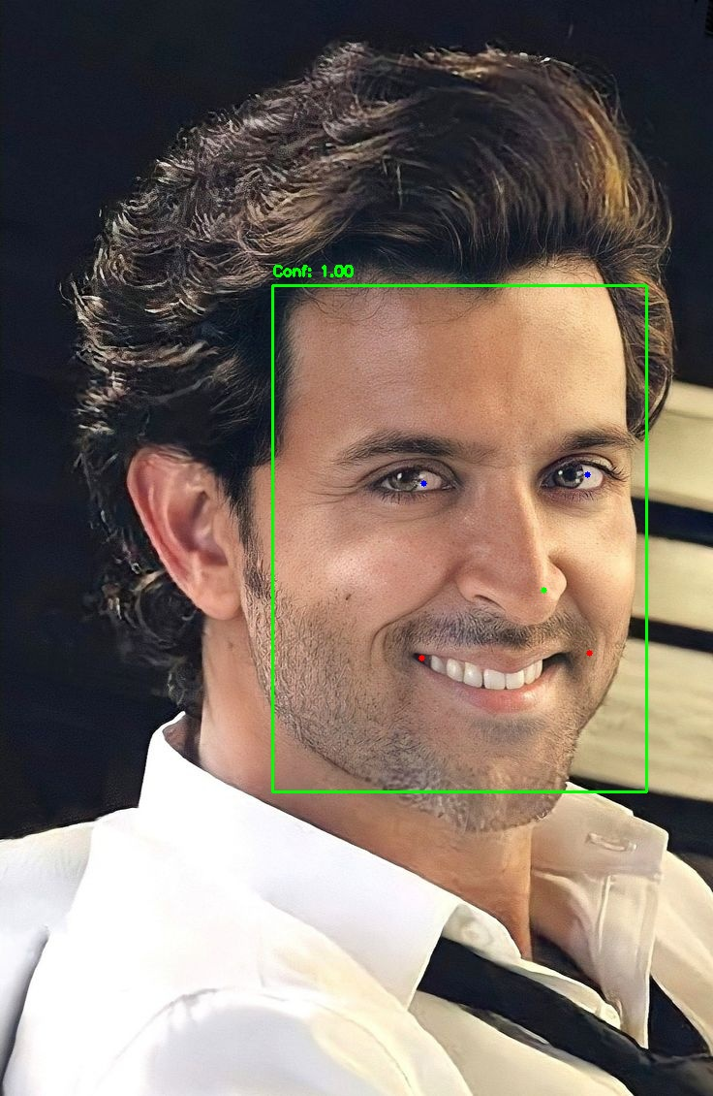
Face Detection
Face Extraction, Resizing and Alignment

5.2.3 Image Enhancement and Normalization
Algorithms and Techniques:
- Color Space Conversion: Converts images to LAB color space for effective color processing.
- Contrast Enhancement: Applies Contrast Limited Adaptive Histogram Equalization (CLAHE) to improve local contrast, especially in the L channel.
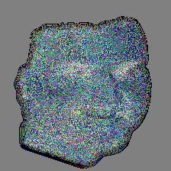
Image Enhancement
- Skin Tone Enhancement: Slightly boosts the red channel to enhance skin tones.
- Noise Reduction: Uses bilateral filtering to reduce noise while preserving facial edges.
- Normalization: Scales pixel values to the range [−1,1][−1,1], optimizing inputs for neural network processing.

Image Normalization
5.2.4 Background Isolation
Algorithms and Techniques:
- Elliptical Masking: Applies an elliptical mask centered on the face based on facial proportions.
- Skin Color Detection: Uses YCrCb color space to identify skin regions.
- GrabCut Segmentation: Refines foreground/background separation for precise face isolation.

Background Isolation
- Edge Smoothing: Applies Gaussian blurring to mask edges for natural transitions.

5.2.5 Preprocessing Flow Chart
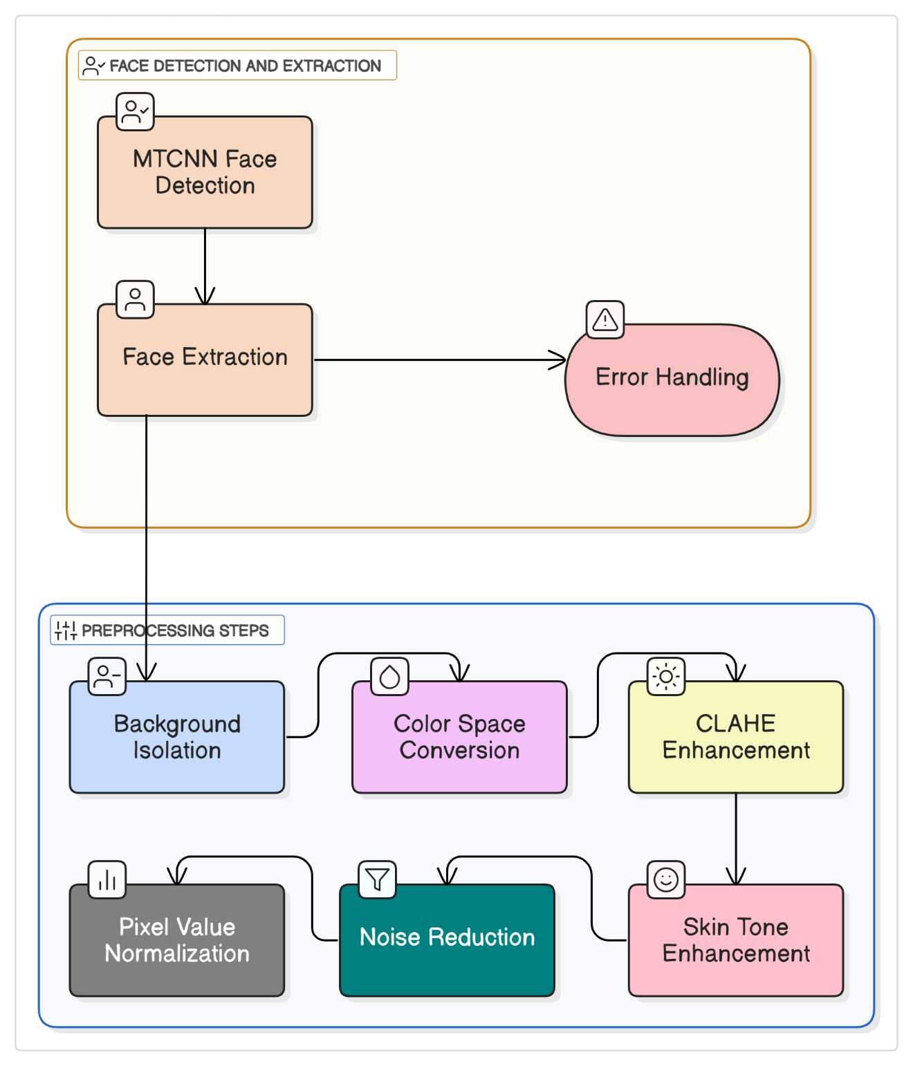
Preprocessing Flow-chart - Albumify

5.3 Classification
Albumify’s classification system integrates deep learning-based face embedding generation with similarity-based matching for robust and scalable recognition.
5.3.1 Face Embedding Generation
Algorithm: Deep Convolutional Neural Network
Process:
- Preprocessed face images are passed through the network to obtain a fixed-length (e.g., 512-dimensional) embedding vector.
- The system supports both single-image and batch processing, utilizing GPU acceleration when available for efficiency.
5.3.2 Similarity Calculation and Matching
Algorithm: Cosine Similarity
Process:
- Compares the embedding of each candidate face with the reference embedding.
- A configurable similarity threshold (default: 0.85) determines if two faces are considered a match.
- The system tracks and reports the highest similarity score for each comparison.
5.3.3 Classification Workflow
Algorithmic Steps:
- Process and embed the reference image.
- For each candidate image:
  - Preprocess and extract face(s).
  - Generate embedding(s).
  - Compute similarity to the reference.
  - Classify as "matched" or "unmatched" based on the threshold.
- Parallel processing is employed for scalability, with robust error handling and logging.
- Results are organized into matched and unmatched directories for user review.
5.3.4 Service Integration
Design: Asynchronous API
Process:
- Supports batch classification requests.
- Returns structured results including confidence scores and error logs.
- Enables integration with the user interface for real-time feedback and review.
5.4 Proposed Model
The core of Albumify’s facial recognition system is a deep learning-based model that integrates advanced architectural features, attention mechanisms, and state-of-the-art loss functions to achieve robust and accurate face identification in collaborative photo collections.
5.4.1 Model Architecture
The model is designed to be modular and configurable, supporting multiple backbone architectures. The primary options include:
- ResNet50V2: A deep residual network with skip connections, well-suited for extracting discriminative facial features and benefiting from transfer learning using pre-trained weights on large datasets such as ImageNet.
- EfficientNet: An optimized architecture balancing network depth, width, and resolution to achieve high accuracy with lower computational cost.
- Custom CNN: The custom CNN is a deep residual network with four convolutional stages, each downsampling the feature maps and increasing filter depth. It optionally applies a channel attention mechanism designed with residual connections, batch normalization, and progressive feature map size reduction for flexibility and efficient training on domain-specific datasets.
The model’s input shape is standardized (e.g., 224×224×3), and the output is a fixed-length embedding vector (typically 512 dimensions) representing the facial features.
5.4.2 Transfer Learning and Base Model Implementation
To leverage existing knowledge, the model uses transfer learning:
- Pre-trained Weights: The backbone (e.g., ResNet50V2 or EfficientNet) is initialized with weights pre-trained on ImageNet.
- Selective Layer Freezing: Early layers are frozen to retain general features, while later layers remain trainable for fine-tuning on the specific facial dataset.
- Global Average Pooling: Reduces spatial dimensions and prepares features for subsequent embedding layers.
This approach enables efficient training and improved generalization, especially when available labeled data is limited.
5.4.3 Attention Mechanism
An attention mechanism is incorporated to enhance the model’s focus on the most informative facial regions:
- Channel Attention: Combines global average and max pooling to capture both average and salient feature responses across channels.
- Bottleneck Structure: Reduces computational overhead while maintaining representational power.
- Sigmoid Activation: Generates attention weights, which are applied to the feature maps to emphasize important facial characteristics.
This mechanism helps the model distinguish subtle differences between faces and improves recognition accuracy, particularly in challenging conditions.

5.4.4 Embedding Layer Design
The embedding stage transforms high-dimensional feature maps into compact, discriminative vectors:
- Progressive Dimension Reduction: Dense layers reduce the feature size (e.g., from 1024 to 512 to the final embedding dimension).
- Regularization: L2 regularization and dropout are applied to prevent overfitting.
- Batch Normalization and PReLU Activation: Enhance training stability and feature representation.
- L2 Normalization: The final embedding is L2-normalized, ensuring that similarity calculations (e.g., cosine similarity) are consistent and meaningful.
5.4.5 Loss Functions
Two advanced loss functions are supported to optimize the model for facial recognition:
- ArcFace Loss: Introduces an angular margin penalty to the target logits, encouraging tighter intra-class clustering and greater inter-class separation. This is achieved by adding a margin to the angle between feature vectors and class centers, followed by a scaling factor for stable training.
- Triplet Loss: Trains the model to minimize the distance between anchor and positive samples (same identity) while maximizing the distance from negative samples (different identities), enforcing a margin for sufficient separation and adding a regularization term for compactness.
These loss functions are critical for learning highly discriminative facial embeddings suitable for large-scale, multi-user photo organization.

5.4.6 Model Architecture Diagram
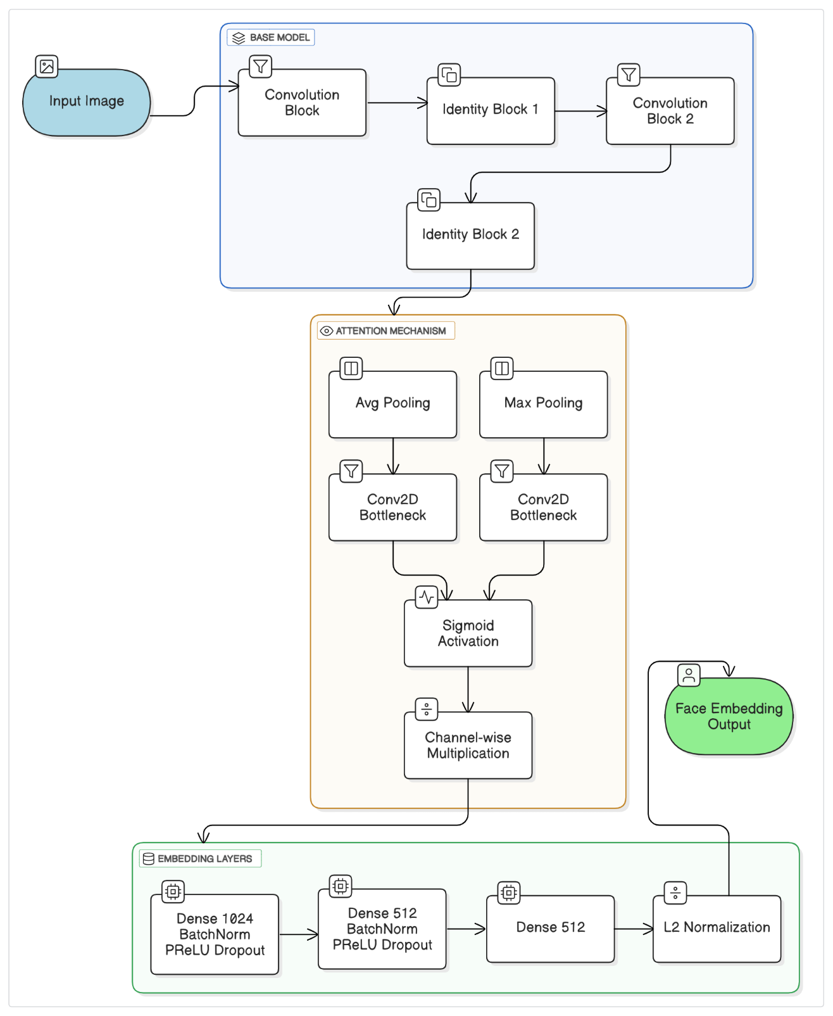
Model Architecture Flow-chart - Albumify

Graphical User Interface
The graphical user interface (GUI) of the Albumify platform is designed to provide a seamless, intuitive, and visually engaging experience for users at every stage—from first visit through photo upload and result download. Below is a structured overview of each core page and its user interactions.
6.1. Home Page
- Purpose:
The Home page serves as the landing screen, introducing users to Albumify’s core value: transforming photo collections into smart, AI-organized albums.

- Key Features:
  - Prominent branding with the "Albumify" heading and a subtitle:
“Where AI Meets Memories – Transform Photos into Smart, Organized Albums”
  - Central Call to Action (CTA) button: "Upload Memories"
    - Navigates to the Signup page if the user is not logged in.
    - Visually distinct with a gradient background and hover animation.

  - Feature Highlights (displayed as cards):
    - Easy Upload: Drag & drop or click to upload.
    - Smart Processing: AI-based photo classification.
    - One Click Upload: Upload a face and let the app classify matches automatically.
6.2. Signup Page
- Purpose:
Allows new users to create an Albumify account.
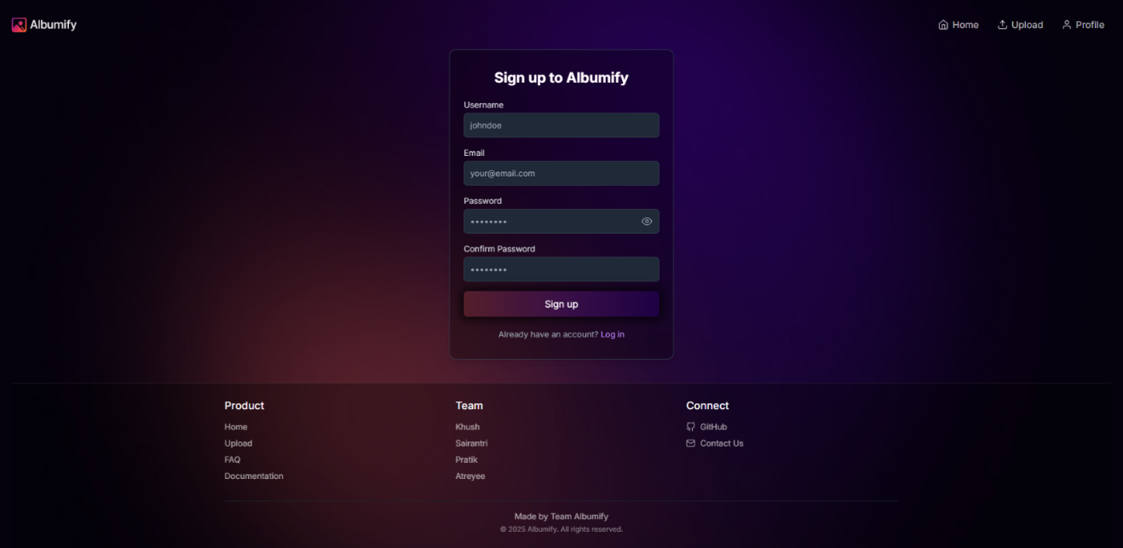
- User Interaction:
  - Form Inputs:
    - Username (min. 3 characters)
    - Email (valid format)
    - Password (min. 6 characters)
    - Confirm Password
    - Real-time validation feedback for each field.
  - Password Visibility Toggle:
    - Eye icon to toggle password visibility.

  - Error Handling:
    - Inline error messages for validation issues.
    - Backend errors (e.g., email already taken) shown in a styled alert.
  - Submit Button:
    - Disabled during processing, shows spinner and “Creating account...” text.
    - On success, redirects to the Upload page.
  - Navigation:
    - Link to Login page for existing users.
6.3. Login Page
- Purpose:
Enables existing users to access their accounts.

- User Interaction:
  - Form Inputs:
    - Email (valid format)
    - Password (min. 6 characters)
    - Real-time validation feedback.

  - Password Visibility Toggle:
    - Eye icon for toggling password visibility.
  - Error Handling:
    - Inline error messages for validation issues.
    - Backend errors (e.g., incorrect credentials) shown in a styled alert.
  - Submit Button:
    - Disabled during processing, shows spinner and “Logging in...” text.
    - On success, redirects to the Upload page.
  - Navigation:
    - Link to Signup page for new users.
6.4. Upload Page
- Purpose:
Allows authenticated users to upload images for face/object recognition.
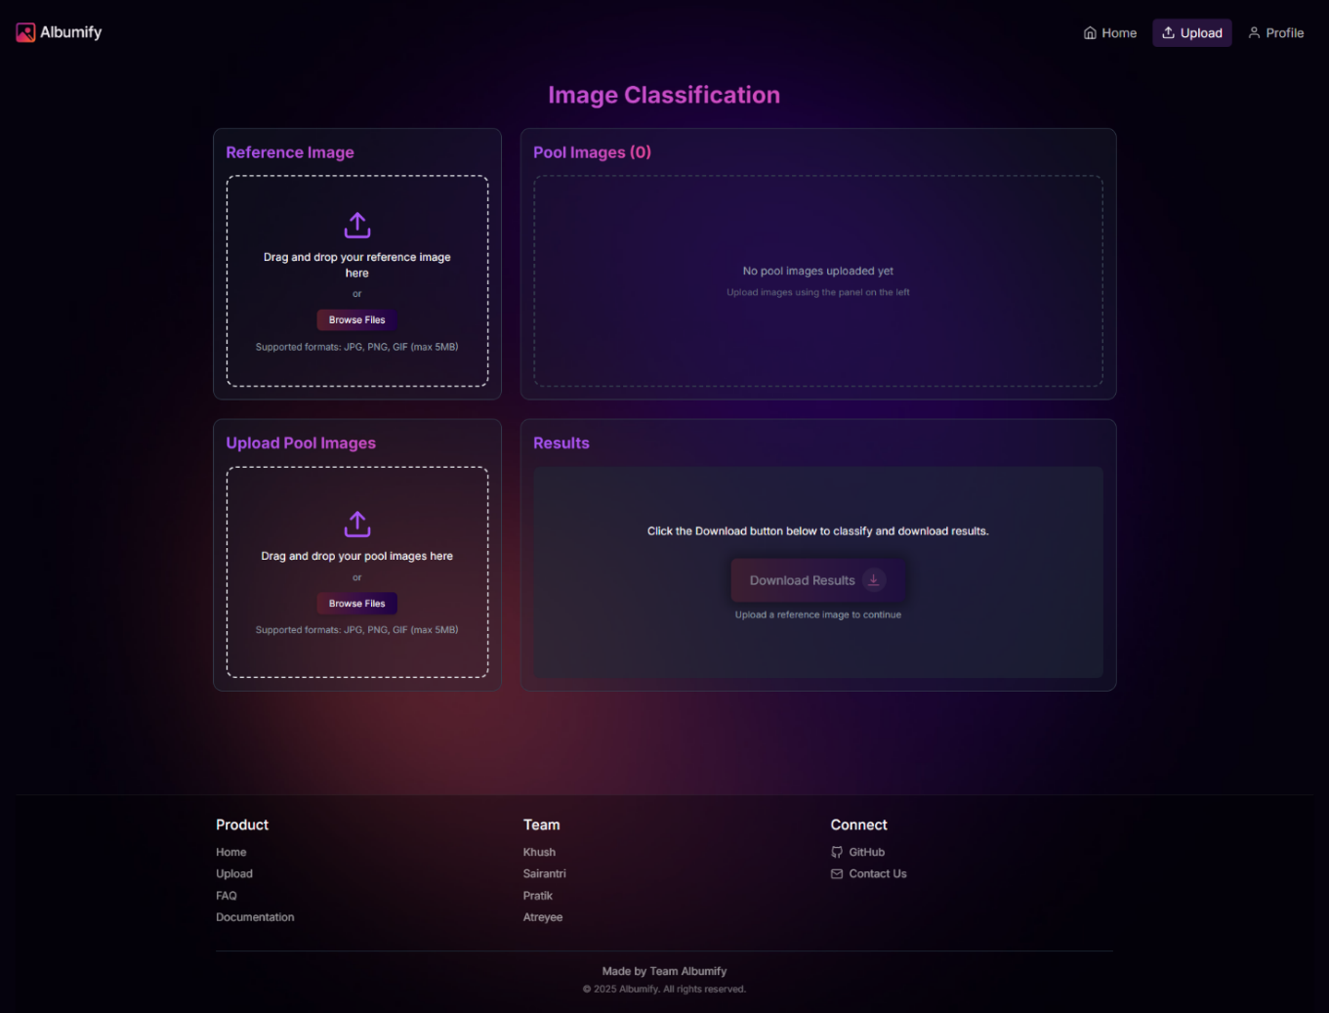

- User Interaction:
  - Image Selection:
    - Upload Reference Images (e.g., face of a specific person).
    - Upload Pool Images (e.g., group/event photos).
    - Thumbnails with filename and delete (❌) icon for each image.
  - Validation & Feedback:
    - At least one reference and one pool image required.
    - Toast error message if requirements not met.
  - Upload & Classify Button:
    - Enabled only when both image sets are present.
    - Shows spinner and “Uploading...” text during processing.
    - On success:
      - Images are uploaded to Cloudinary.
      - Metadata saved in MongoDB.
      - Classification triggered.
      - Toast success message: “Images uploaded successfully.”
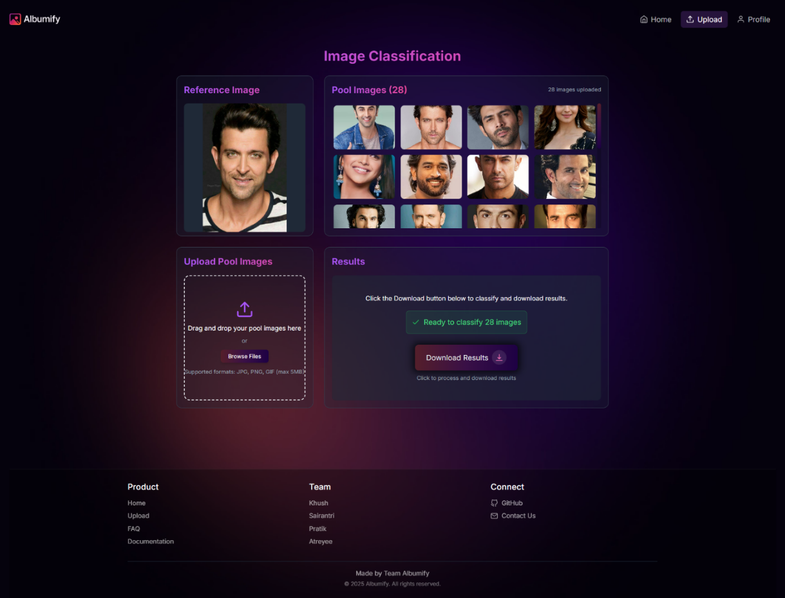
  - File Handling:
    - Accepts common image formats (JPG, PNG, etc.).
    - Restricts unsupported types and large files (if implemented).
  - Visual Layout:
    - Clear sections for Reference and Pool uploads.
    - Responsive scrolling, consistent styling for messages.
6.5 Download Results Feature
- Purpose:
Lets users download the classified results from their latest upload session.

- User Interaction:
  - Download Button:
    - Appears after successful classification.
    - Initiates backend request for processed results.
    - Automatically downloads a ZIP file containing matched images.
    - Shows spinner or disables button during processing.
    - Displays error messages via toast/alert if download fails.

  - Result Content:
    - ZIP file includes:

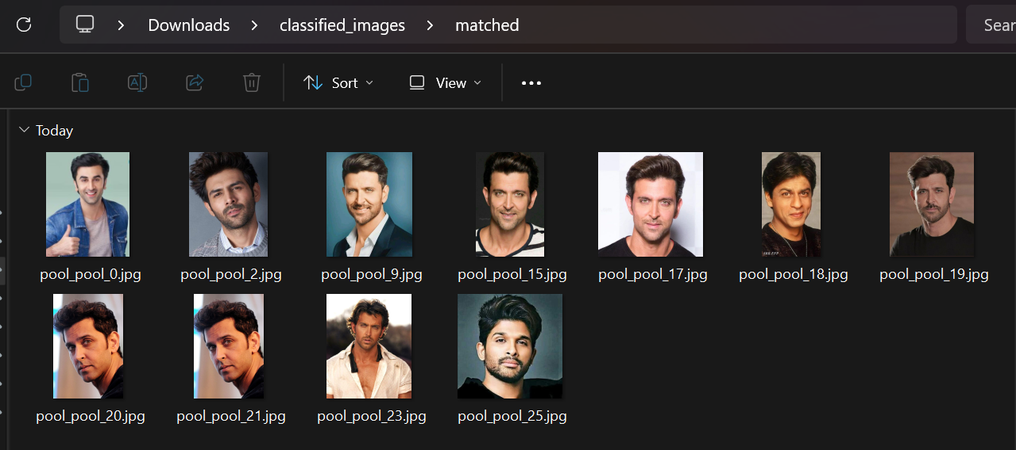
Matched images (from the pool matching the reference).

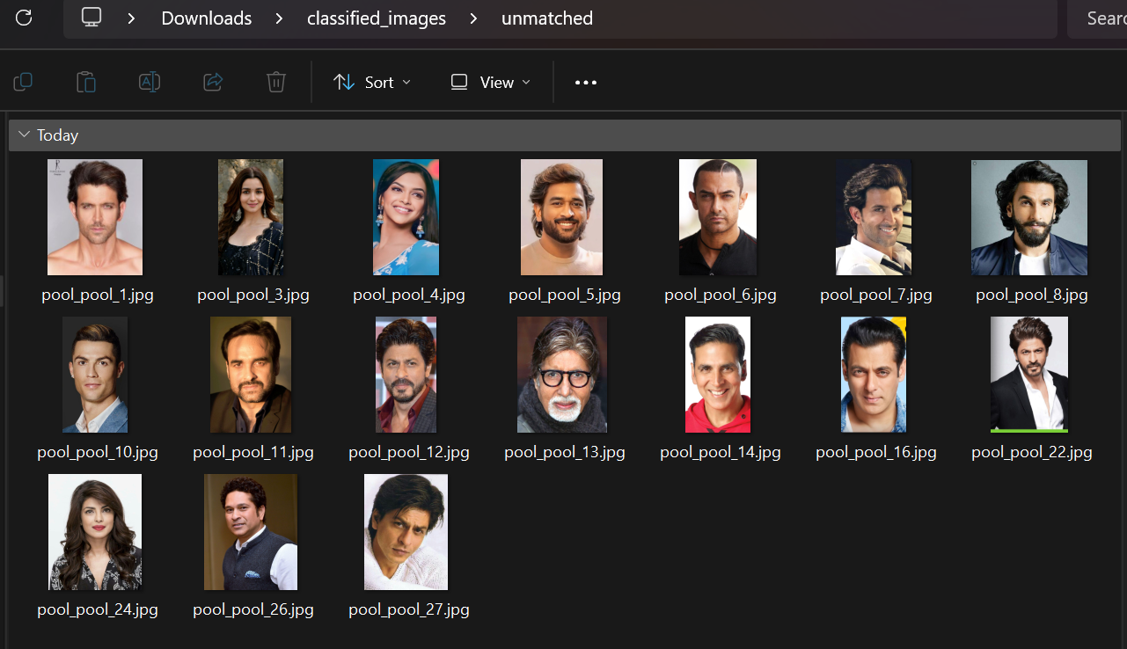
Unmatched images (from the pool not matching the reference).

6.6. Summary Table: Core GUI Pages
Page | Main Purpose | Key Interactions/Elements
Home | Introduce Albumify, encourage sign-up/upload | Branding, CTA button, feature cards
Signup | Account creation | Form with validation, password toggle, error handling
Login | User authentication | Form with validation, password toggle, error handling
Upload | Image upload & classification | Reference/Pool uploads, previews, validation, upload button
Download | Retrieve results | Download button, ZIP file, error handling

The Albumify GUI is crafted to maximize usability, guide users through each step, and ensure a visually consistent and responsive experience across all core report pages.

System Design
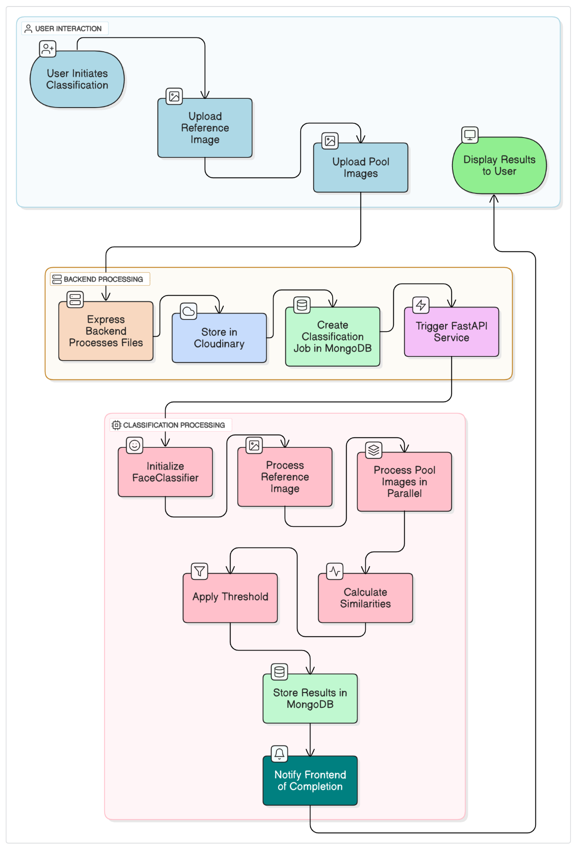
System Architecture - Albumify
7.1 Architectural Design
7.1.1. System Architecture
- Architecture Type: Full-Stack Web Application
- Architectural Pattern: Based on Microservices Architecture approach with clear separation of concerns

7.1.2. Technology Stack

Frontend
- Framework: React.js
- State Management: Using Zustand
- UI Components: Modular component-based design
- Key Features:
  - Responsive design
  - Intuitive user interface
  - Dynamic content rendering
  - Client-side form validation
Backend
- Language: Python
- Framework: Flask
- Machine Learning Components:
  - Face recognition model
  - Image Processing algorithm
  - Image classification algorithm
  - Clustering of similar images

Infrastructure
- Authentication: Token-based authentication
- File Storage: Temporary file handling for uploads
- Database: MongoDB to store user credentials and Cloudinary to store images
- Data Processing: Server-side image processing

User Registration
Registration Page
Home Page

Detail Validation
Welcome Page
Login Page
Credential Input
Success
Auth Failure
Auth Options
Auth Success
Failure

Successful Login
Various Download Options
Face Detection
Session Termination
Processing State
Logout Process
Upload Error
Valid
Invalid
Validation
Image Cluster Upload
Backend Submission
Reference Image Upload
Upload Page
Processing State
(Backend Py Model)
Result Page
User Logout
Image Grouping
Image Processing
Result Preparation

Classified Grid Display

Classification

Complete

Image

Submission

Cluster Generation

Cache Clearing
Flow-Control Diagram
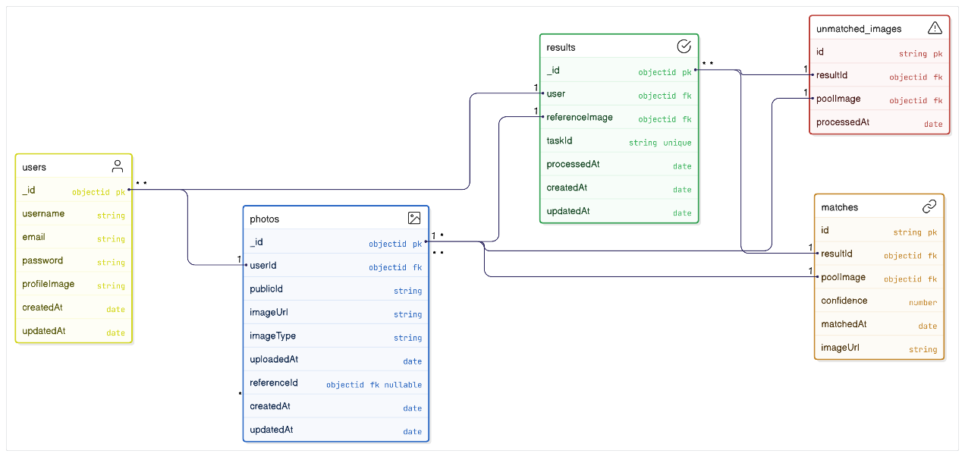
ER Diagram - Albumify
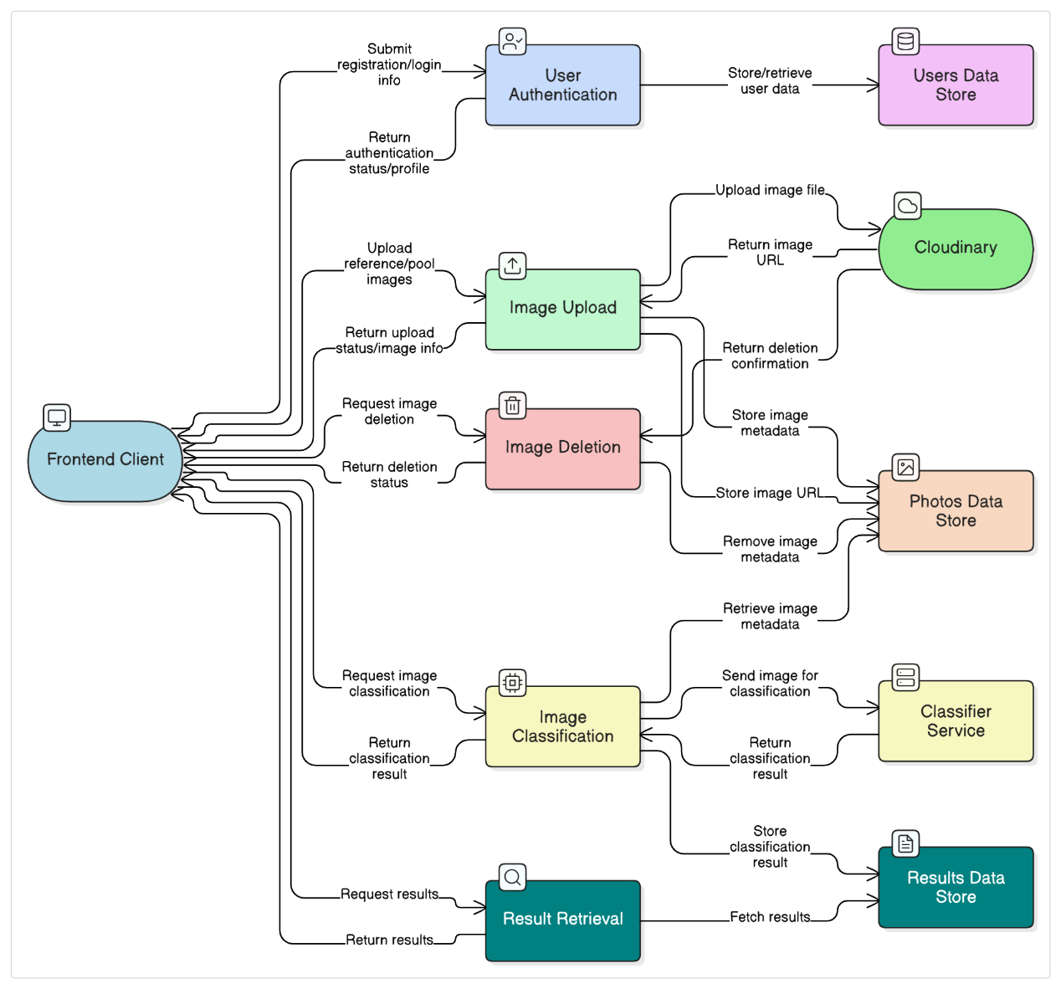
Data Flow Diagram - Albumify
Experimental Results
This report presents a comprehensive analysis of the experimental results obtained from training (trained on VGGFace2 Dataset with 1.7 Lakh Images and 480 classes) and testing (tested on LFW - Deepfunneled Dataset consisting of 13.2k images with 5.6k identities) of the custom CNN face recognition model implementation. The model was designed to encode facial images into discriminative feature embeddings that allow for accurate identity verification and recognition. Four key performance metrics are analyzed: similarity distribution, precision-recall characteristics, embedding quality through t-SNE visualization, and ROC curve performance.
8.1. Custom CNN Model Description
- Input:
The model takes an input tensor with shape defined by self.config.input_shape (default (224, 224, 3)).
- Convolutional Blocks with Residual Connections:
The architecture consists of four convolutional blocks, each with residual connections to help gradient flow and improve training stability.
  - First Conv Block:
    - Two convolutional layers with 32 filters each, kernel size 3, strides 1 and 2 respectively.
    - Residual connection is saved after the second conv layer.
  - Second Conv Block:
    - Two convolutional layers with 64 filters each, kernel size 3, strides 1 and 2 respectively.
    - Residual connection from the previous block is projected (1x1 conv with stride 2) to match dimensions and added to the output.

  - Third Conv Block:
    - Two convolutional layers with 128 filters each, kernel size 3, strides 1 and 2 respectively.
    - Residual connection from the previous block is projected similarly and added.
  - Fourth Conv Block:
    - Two convolutional layers with 256 filters each, kernel size 3, strides 1 and 2 respectively.
    - Residual connection from the previous block is projected and added.
- Attention Mechanism: If self.config.use_attention is True, a spatial attention block is applied after the last convolutional block. This attention block computes channel-wise attention by combining global average pooling and max pooling, followed by convolution and sigmoid activation to recalibrate feature maps.
- Global Average Pooling: After the convolutional and attention blocks, a global average pooling layer reduces the spatial dimensions, producing a fixed-length feature vector.
- Output: The model outputs this feature vector, which serves as a base embedding for further processing in the full face recognition model.
8.2. Similarity Distribution Analysis
The similarity distribution plot reveals a clear separation between genuine pairs (same identity) and impostor pairs (different identity):
- Same Identity Pairs: The distribution for same identity comparisons peaks at high similarity values (approximately 0.95-0.98), indicating strong cohesion within identity classes.
- Different Identity Pairs: The distribution for different identity comparisons centers around lower similarity values (approximately 0.80-0.85), showing good separation from genuine matches.
- Optimal Threshold: The model establishes an optimal verification threshold at 0.854 (indicated by the red dashed line), carefully balancing false acceptances and rejections.
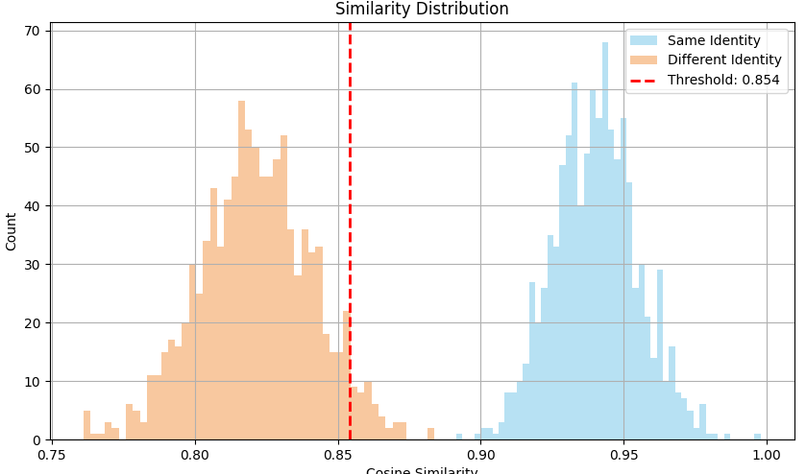
The minimal overlap between the two distributions indicates that the embedding space effectively differentiates between identities, which is essential for reliable face verification.
8.3. Precision-Recall Performance
The precision-recall curve provides insight into the model's verification capabilities:
- PR AUC: The area under the precision-recall curve is 0.829, demonstrating strong overall performance.
- High-Precision Region: The model maintains perfect precision (1.0) up to approximately 0.6 recall, indicating that the highest-confidence matches are extremely reliable.
- Performance Degradation Pattern: Precision begins to decrease noticeably after 0.6 recall, with a steeper decline after 0.8 recall, highlighting the increasing difficulty in maintaining precision as the model attempts to identify more difficult matches.
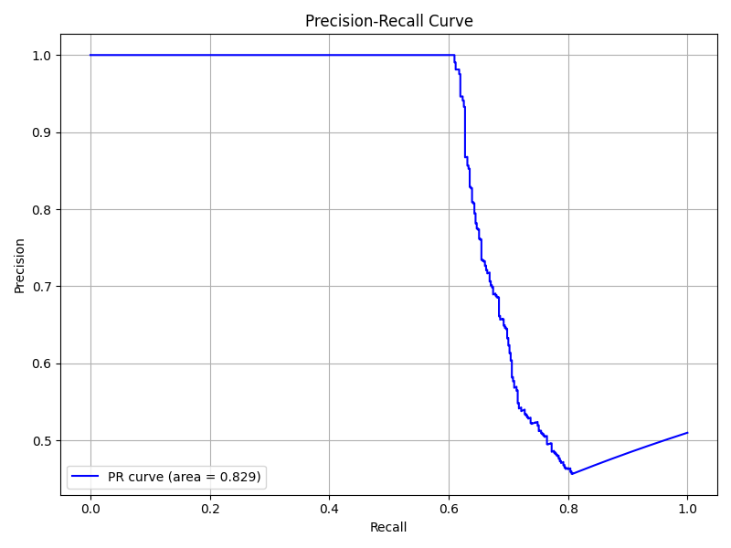
This curve is particularly valuable as it demonstrates the model's effectiveness in imbalanced classification scenarios, which are common in face verification systems.
8.4. Embedding Quality Analysis
The t-SNE visualization of face embeddings provides qualitative evidence of the model's discriminative power:
- Clear Cluster Formation: The visualization shows 10 distinct clusters (labeled 0-9), each representing a different identity class.
- Intra-Class Cohesion: Points of the same color (same identity) form tight, compact clusters, indicating high similarity within the same identity.
- Inter-Class Separation: Different colored clusters are well-separated in the 2D projection space, demonstrating effective discrimination between different identities.
- Consistent Separation Distance: The embedding space maintains relatively uniform distances between different identity clusters, suggesting balanced discrimination capabilities across the identity space.
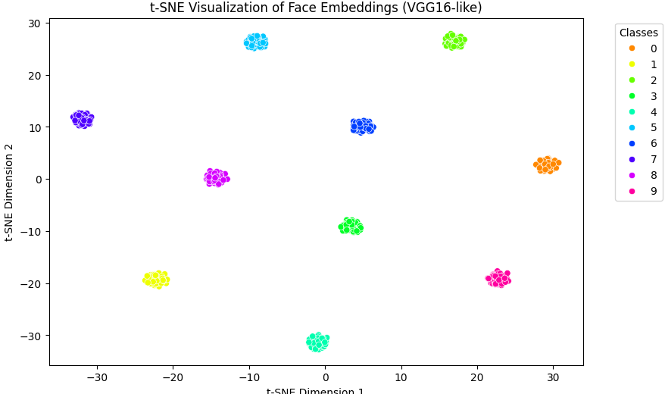
This visualization confirms that the model has learned a feature space where faces of the same person are mapped closely together while maintaining clear boundaries between different individuals.
8.5. ROC Curve Analysis
The Receiver Operating Characteristic (ROC) curve provides a comprehensive view of the verification performance across different thresholds:
- ROC AUC: The Area Under the Curve is 0.8466, indicating strong discrimination ability.
- Curve Profile: The curve rises steeply in the low FPR region, showing that the model achieves high true positive rates before incurring significant false positives.
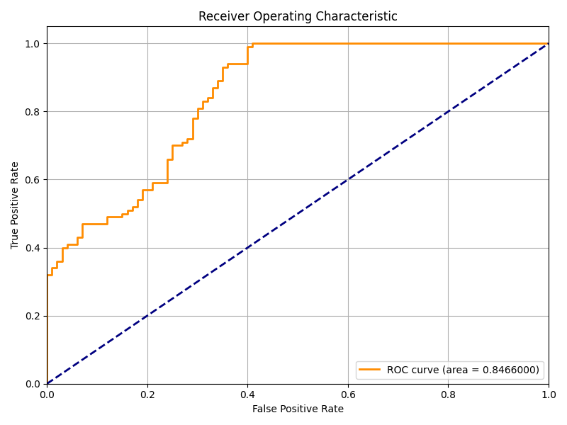
- Operating Point: The curve shows that the model can achieve approximately 0.95 true positive rate at a false positive rate of 0.4.
- Baseline Comparison: The diagonal dashed line represents random chance performance, and the significant gap between this and the actual curve confirms the model's effectiveness.
8.6. Performance Summary
The experimental results demonstrate a face recognition model with strong verification capabilities:
- Embedding Quality: The t-SNE visualization and similarity distribution confirm that the model creates well-clustered, discriminative embeddings for face recognition.

- Verification Performance:
Metric | Value
Optimal Similarity Threshold | 0.854
PR AUC | 0.829
ROC AUC | 0.847
t-SNE Clustering Quality | Distinct clusters, minimal overlap
Same Identity Mean Similarity | ≈0.94–0.98
Different Identity Mean Similarity | ≈0.80–0.85
Overall Accuracy | ≈82%

- Class Separability: The clear separation in the similarity distributions and distinct clusters in the t-SNE plot indicate excellent class discrimination.
- Operational Characteristics: The precision-recall curve suggests that the model can be confidently tuned for high-precision applications by adjusting the threshold, albeit with a trade-off in recall.

Conclusion

The project discussed above provides the foundational technology for "Albumify," a platform designed to revolutionize photo management for shared events and galleries. By leveraging advanced face recognition and classification techniques, the project automates the identification and categorization of images based on user-specified faces.

The implemented pipeline, comprising robust face detection, alignment, normalization, and embedding generation using deep learning models, ensures high accuracy and reliability in face classification. Features like batch processing, visualization, and customizable similarity thresholds enhance the user experience, making the system adaptable to diverse photo datasets. Additionally, the ability to process large collections efficiently and save results in organized directories significantly reduces manual effort.

"Albumify" addresses a critical need in the digital age: managing and curating large, shared photo collections with ease. By streamlining photo organization through automation, the project not only saves time but also fosters better collaboration and sharing among users, setting a new standard for event-based photo management solutions.

Future Scope

1. Enhanced Feature Recognition
- Activity-Based Categorization: Extend the model to recognize activities or scenes within photos (e.g., "birthday party," "concert").
- Expression Analysis: Enable sorting based on facial expressions (e.g., smiles, surprise).
- Multi-Label Classification: Allow categorization by multiple criteria such as location, attire, or event type.

2. Scalability and Integration
- Integration with Photo Platforms: Collaborate with popular platforms like Google Photos or social media for direct import and export of images.

3. Improved Accuracy
- Advanced Models: Upgrade the face recognition model using state-of-the-art architectures like Vision Transformers (ViT).
- Personalization: Implement transfer learning for personalized face models tailored to individual users or groups.

4. Mobile and Cross-Platform Support
- Create a mobile app to allow users to organize photos on-the-go, leveraging device cameras for real-time categorization.
- Develop cross-platform compatibility for seamless operation on various devices and operating systems.

References

- F. Schroff, D. Kalenichenko and J. Philbin, "FaceNet: A unified embedding for face recognition and clustering," 2015 IEEE Conference on Computer Vision and Pattern Recognition (CVPR), Boston, MA, USA, 2015, pp. 815-823, doi: 10.1109/CVPR.2015.7298682. keywords: {Face;Face recognition;Training;Accuracy;Artificial neural networks;Standards;Principal component analysis}

- W. Liu, Y. Wen, Z. Yu, M. Li, B. Raj and L. Song, "SphereFace: Deep Hypersphere Embedding for Face Recognition," 2017 IEEE Conference on Computer Vision and Pattern Recognition (CVPR), Honolulu, HI, USA, 2017, pp. 6738-6746, doi: 10.1109/CVPR.2017.713. keywords: {Face;Training;Measurement;Face recognition;Manifolds;Testing;Feature extraction}

- H. Wang et al., "CosFace: Large Margin Cosine Loss for Deep Face Recognition," 2018 IEEE/CVF Conference on Computer Vision and Pattern Recognition, Salt Lake City, UT, USA, 2018, pp. 5265-5274, doi: 10.1109/CVPR.2018.00552. keywords: {Face;Face recognition;Testing;Mars;Training;Feature extraction;Task analysis}

- J. Deng, J. Guo, J. Yang, N. Xue, I. Kotsia and S. Zafeiriou, "ArcFace: Additive Angular Margin Loss for Deep Face Recognition," in IEEE Transactions on Pattern Analysis and Machine Intelligence, vol. 44, no. 10, pp. 5962-5979, 1 Oct. 2022, doi: 10.1109/TPAMI.2021.3087709. keywords: {Face recognition;Training;Noise measurement;Training data;Additives;Predictive models;Data models;Large-scale face recognition;additive angular margin;noisy labels;sub-class;model inversion}

- Y. Taigman, M. Yang, M. Ranzato and L. Wolf, "DeepFace: Closing the Gap to Human-Level Performance in Face Verification," 2014 IEEE Conference on Computer Vision and Pattern Recognition, Columbus, OH, USA, 2014, pp. 1701-1708, doi: 10.1109/CVPR.2014.220. keywords: {Face;Three-dimensional displays;Training;Face recognition;Agriculture;Solid modeling;Shape}

- https://www.linkedin.com/pulse/photo-management-anxiety-greg-mclean
- https://www.tidy.haus/blog/the-challenges-of-online-photo-management
- https://arxiv.org/pdf/1907.12739/1000.pdf
- https://support.microsoft.com/en-us/office/group-photos-by-people-21065f48-c746-48ad-a98a-cbe4631631bc
- https://www.relauncher.com.au/blog/the-biggest-problems-with-digital-photo-management
- https://www.ijsrtjournal.com/article/AIDriven-Facial-RecognitionBased-Photo-Retrieval-System-for-Event-Management
- https://visionify.ai/how-to-improve-image-processing-in-facial-recognition-systems/
- https://paperswithcode.com/dataset/lfw
- https://www.kaggle.com/datasets/jessicali9530/lfw-dataset
- https://www.aiaaic.org/aiaaic-repository/ai-algorithmic-and-automation-incidents/megaface-dataset
- https://chalearnlap.cvc.uab.cat/challenge/33/track/33/metrics/
- https://www.youtube.com/watch?v=j8JT1lvB3a8
- https://www.multcloud.com/explore/why-cant-i-see-a-shared-album-in-google-photos-0121-ac.html
- https://www.youtube.com/watch?v=3PYDD8b-GX4
- https://www.iplabs.com/blog/the-4-main-challenges-of-photo-product-management

